URL: https://adityabirlahospital.com/doctors/gastroenterologist-in-pune

Meta Title: Best Gastroenterologists In Pimpri Chinchwad, Pune | ABMH

Meta Description: Consult the best gastroenterologists in Pimpri Chinchwad at Aditya Birla Hospital. Expert care for all digestive and liver-related issues. Book an appointment now!

Best Gastroenterologists In Pimpri-Chinchwad Pune
A gastroenterologist, commonly known as a stomach specialist or liver doctor, provides treatment for digestive system issues. Our gastrointestinal specialists treat issues with the stomach, intestines, liver, and other related organs. These professionals are skilled in managing a wide range of gastrointestinal issues and perform procedures like Endoscopy and ERCP, and EUS (Endoscopic Ultrasound).

Our Team of the Best Gastroenterology Doctors in Pune

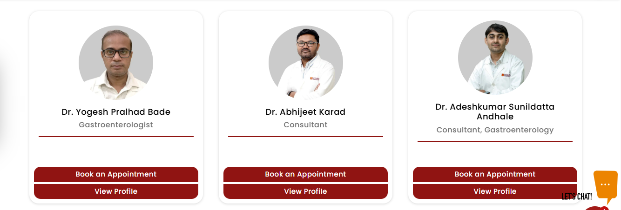

Our team of gastroenterologists in Pune at our Gastroenterology Hospital in Pimpri Chinchwad Pune is dedicated to providing expert care for all your digestive health needs. Whether you are looking for a stomach specialist doctor or require advanced treatment from a surgical gastroenterologist, our specialists are equipped to deliver personalized solutions tailored to your specific conditions.

Our Gastroenterologists Treat the Following Conditions:

Acid Reflux & GERD Treatment
Management of gastroesophageal reflux disease (GERD) with medications and lifestyle adjustments.

Irritable Bowel Syndrome (IBS)
Treatment for IBS, address symptoms like bloating, diarrhea, and constipation.

Crohn’s Disease & Ulcerative Colitis
Medical and surgical management of inflammatory bowel diseases (IBD), including flare-ups and long-term care.

Endoscopy & Colonoscopy
Diagnostic procedures to identify conditions like ulcers, cancers, and polyps in the digestive tract.

Liver Diseases
Treatment for conditions such as fatty liver, cirrhosis, hepatitis, and liver cancer.

Gallbladder Disorders
Management of gallstones, cholecystitis (inflammation), and gallbladder removal.

Pancreatitis
Treatment for acute and chronic inflammation of the pancreas, including nutritional support and pain management.

Celiac Disease
Diagnosis and management of celiac disease, including dietary recommendations and monitoring.

Endoscopic Ultrasound (EUS)
Non-invasive procedure for imaging the pancreas, bile ducts, and gastrointestinal tract to diagnose various conditions.

ERCP (Endoscopic Retrograde Cholangiopancreatography)
A procedure for diagnosing and treating bile duct and pancreatic duct problems, including blockages and stones.

Gastrointestinal Cancer Care
Early detection and management of cancers such as colorectal cancer, stomach cancer, and esophageal cancer.

Hepatitis B & C Treatment
Specialized care for viral hepatitis, including antiviral treatments and monitoring.

Constipation & Diarrhea Management
Diagnosis and treatment of chronic constipation and diarrhea, including medications and dietary changes.

Bile Duct Obstruction
Management of blockages in the bile ducts, often treated with ERCP or surgery.

How Do I Find the Best Gastroenterologist Near Me in Pune?

If you’re in search of the best gastroenterologist or surgical gastroenterologist near you in PCMC, meet our team of experts for a comprehensive approach to gastrointestinal health. You can reach us easily from several nearby locations.

Nearby Locations:

Hinjewadi, Wakad, Baner, Aundh, Pimple Saudagar, Bhosari, Ravet, Chinchwad Gaon, Tathawade, Nigdi, PCMC, Pimpri, Moshi, and Chakan

